
DEPARTMENT OF COMPUTER SCIENCE AND DATA SCIENCE
DBMS MINI Project Report (BCS403)
On
PORTFOLIO ANALYTICS

Submitted by
CHARAN KA
4PM22CD009
Submitted To
Dr. Sunitha B S
HOD -CSDS Department

MARKS AWARDED
Presentation(5M) | Report (5M) | Total (10M) | Faculty Sign with Date

COORDINATER : HOD:

Mrs. Sheethal Lobo Dr. Sunitha B S

……………… ……………..
TABLE OF CONTENTS
Cover Page | (i)
Certificate | (ii)
Abstract | (ii)

Chapter No | Chapter Description | Page No.
CHAPTER-1 | INTRODUCTION | 1
1.1 | Overview of Portfolio Analytics | 1
1.2 | Objectives | 2
1.3 | About DBMS | 6
1.4 | About RDBMS | 6
CHAPTER-2 | SYSTEM REQUIREMENTS SPECIFICATION | 4
2.1 | Software Requirements | 7
2.2 | Hardware Requirements | 7
2.3 | Technologies used | 7
2.4 | About tool used | 7
2.5 | About Programming Language | 8
CHAPTER-3 | SYSTEM DESIGN | 9
3.1 | Schema Diagram | 9
3.2 | ER Diagram | 9
CHAPTER-4 | SYSTEM IMPLEMENTATION | 10
4.1 | Modules | 11
CHAPTER-5 | SNAPSHOTS AND RESULTS | 13
5.1 | Report of orders page | 13
5.2 | Report of Inventory page | 13
5.3 | Report of Staff page | 14
CHAPTER-6 | CONCLUSION | 15

ABSTRACT
Portfolio analytics is a vital discipline within finance, leveraging data-driven insights to optimize investment portfolios. It encompasses data management, performance measurement, risk assessment, asset allocation, reporting, and decision support. By analyzing historical performance and assessing future risks, portfolio analytics aids in constructing well-balanced portfolios that align with investor objectives and risk tolerance. It plays a crucial role in enhancing decision-making processes, ensuring compliance with regulatory standards, and maximizing returns while managing risks effectively. As technology evolves, portfolio analytics continues to evolve, offering increasingly sophisticated tools to navigate dynamic financial markets and achieve optimal investment outcomes.
Portfolio analytics is a critical tool in modern finance, offering invaluable insights into the performance, risk, and optimization of investment portfolios. By harnessing data from various sources and employing sophisticated analytical techniques, portfolio analytics enables investors and asset managers to make informed decisions that align with their financial objectives and risk tolerance.
At its core, portfolio analytics involves several key components: data management, performance measurement, risk assessment, asset allocation, reporting, and decision support. These components work synergistically to provide a holistic view of portfolio dynamics, from understanding historical performance to forecasting future outcomes under different scenarios.
The significance of portfolio analytics lies in its ability to enhance decision-making processes. By calculating risk-adjusted returns, assessing portfolio diversification, and optimizing asset allocations based on investor preferences and market conditions, portfolio analytics helps mitigate risks and maximize returns. Moreover, compliance with regulatory standards and reporting requirements ensures transparency and accountability in portfolio management practices.

CHAPTER-1
INTRODUCTION
1.1 OVERVIEW OF PORTFOLIO ANALYTICS:
Portfolio analytics is a critical component of investment management that involves the systematic evaluation of portfolios to optimize returns, manage risk, and align with strategic objectives. It integrates quantitative techniques, financial theories, and technological tools to analyze and improve portfolio performance, providing insights into various aspects such as asset allocation, diversification, risk management, and performance measurement.

Key Aspects of Portfolio Analytics
- Performance Measurement: Metrics like the Sharpe ratio, Jensen’s alpha, and the Information ratio are used to evaluate the efficiency and effectiveness of the portfolio in generating returns relative to the risk taken.
- Risk Analysis: Involves assessing the risk profile of the portfolio using measures such as Value-at-Risk (VaR), beta, and standard deviation. It also examines the exposure to different types of risks, including market, credit, and liquidity risks.
- Asset Allocation: The process of distributing investments across various asset classes, such as equities, bonds, and real estate, to balance risk and return. This is based on the investor’s goals, risk tolerance, and market conditions.
- Diversification: A strategy to reduce risk by investing in a variety of assets. Diversification aims to minimize the impact of any single investment’s poor performance on the overall portfolio.
- Performance Attribution: Analyzes the sources of returns by distinguishing between market effects, asset allocation decisions, and security selection. It helps identify which factors contributed positively or negatively to portfolio performance.
- Scenario Analysis and Stress Testing: Simulates various economic and market scenarios to assess how the portfolio would perform under different conditions. This helps in understanding potential risks and making informed decisions to mitigate them.
Advancements in technology, such as machine learning and big data analytics, have significantly enhanced the capabilities of portfolio analytics. These tools enable more sophisticated modeling, real-time data analysis, and improved decision-making processes, thereby enhancing the ability to achieve better risk-adjusted returns. Portfolio analytics is essential for ensuring that investment portfolios are well-structured, resilient, and aligned with the investor's financial goals.
1.2 OBJECTIVES:
Portfolio analytics serves multiple key objectives that are crucial for optimizing investment portfolios and aligning them with investor goals. These objectives encompass performance enhancement, risk management, strategic alignment, and compliance with regulatory requirements. Below are the primary objectives of portfolio analytics:

1. Performance Optimization
- Maximize Returns: Enhance the portfolio’s return by identifying opportunities for asset allocation and security selection that outperform the market.
- Benchmark Comparison: Assess the portfolio’s performance against relevant benchmarks to ensure it meets or exceeds expected performance standards.

2. Risk Management
- Risk Identification: Identify various types of risks (e.g., market risk, credit risk, liquidity risk) inherent in the portfolio.
- Risk Mitigation: Develop strategies to mitigate identified risks through diversification, hedging, and other risk management techniques.
- Risk-Adjusted Returns: Focus on achieving favorable risk-adjusted returns, balancing the potential gains with the level of risk undertaken.

3. Asset Allocation
- Optimal Distribution: Allocate assets efficiently across various asset classes (equities, bonds, real estate, etc.) to align with investment goals and risk tolerance.
- Rebalancing: Periodically adjust the portfolio to maintain the desired asset allocation and respond to changing market conditions.

4. Diversification
- Reduce Volatility: Lower the overall portfolio risk by diversifying investments across different sectors, geographies, and asset types.
- Enhance Stability: Ensure that the impact of poor performance in one area is offset by better performance in another, leading to more stable returns.

5. Performance Attribution
- Source Analysis: Analyze the sources of portfolio returns to distinguish between gains from market movements, asset allocation decisions, and individual security performance.
- Informed Decisions: Use performance attribution to make informed decisions about future investment strategies and adjustments.

6. Scenario Analysis and Stress Testing
- Future Projections: Conduct scenario analysis to predict portfolio behavior under different economic and market conditions.
- Resilience Testing: Perform stress testing to evaluate how the portfolio would perform during extreme market events and ensure it can withstand adverse conditions.

7. Strategic Alignment
- Goal Alignment: Ensure that the portfolio strategy aligns with the investor’s overall financial goals, risk appetite, and investment horizon.
- Tactical Adjustments: Make tactical adjustments to the portfolio in response to evolving market trends and economic forecasts.

8. Regulatory Compliance
- Adherence to Guidelines: Ensure that the portfolio complies with relevant regulatory requirements and industry standards.
- Reporting and Transparency: Maintain transparency through accurate reporting and disclosure of portfolio performance, risks, and strategies.

9. Cost Efficiency
- Minimize Costs: Optimize portfolio management costs, including transaction fees, taxes, and management expenses, to enhance net returns.
- Efficient Execution: Implement cost-effective trading and management practices to maximize value for investors.

Improved User Experience:
Enhancing the user experience (UX) in portfolio analytics involves creating intuitive, efficient, and engaging tools that cater to the needs of both novice and professional investors. The goal is to simplify complex data and processes, provide actionable insights, and offer a seamless interaction that supports effective decision-making. Below are key strategies and features to improve the UX in portfolio analytics:

1. Intuitive Interface Design
- Simplified Navigation: Ensure that the platform is easy to navigate with a clear, logical structure that guides users through various functionalities.
- Visual Clarity: Use clean and straightforward designs with consistent color schemes, fonts, and iconography to enhance readability and reduce cognitive load.
- Personalization: Allow customization of dashboards and reports to display the most relevant data and metrics based on user preferences.

2. Interactive Data Visualization
- Dynamic Charts and Graphs: Implement interactive visual tools like heat maps, line charts, pie charts, and bar graphs to help users quickly grasp trends, correlations, and portfolio performance.
- Drill-Down Capabilities: Provide options to drill down into detailed data from summary views, enabling users to explore specific aspects of the portfolio in depth.
- Real-Time Updates: Ensure that visualizations reflect real-time data for accurate and timely decision-making.

3. Comprehensive Insights and Analytics
- Customizable Reports: Offer the ability to generate tailored reports that meet specific requirements, including performance summaries, risk assessments, and scenario analyses.
- AI-Driven Insights: Use artificial intelligence to provide predictive analytics, personalized recommendations, and anomaly detection, enhancing the value of the insights provided.
- Scenario Analysis Tools: Incorporate tools for scenario analysis and stress testing to help users assess the potential impact of various market conditions on their portfolios.

4. Streamlined Data Integration
- Data Aggregation: Support integration with multiple data sources and platforms to consolidate information from various accounts, asset classes, and financial institutions.
- Automated Data Entry: Minimize manual data entry through automation, reducing errors and saving time for users.
- APIs and Connectors: Use APIs and other connectors to enable seamless data flow between different systems and analytical tools.

5. Enhanced Accessibility
- Mobile Compatibility: Ensure the platform is fully responsive and accessible on mobile devices, allowing users to manage portfolios on the go.
- Voice Commands: Integrate voice-activated commands and natural language processing to facilitate hands-free interactions and simplify complex queries.
- Accessibility Features: Implement features such as screen reader compatibility, high-contrast modes, and adjustable font sizes to accommodate users with disabilities.

6. Efficient Performance Monitoring
- Real-Time Alerts: Provide real-time notifications and alerts for critical events, such as significant portfolio value changes, risk thresholds breaches, and investment opportunities.
- Performance Benchmarks: Include tools for comparing portfolio performance against industry benchmarks and personalized goals.
- At-a-Glance Summaries: Offer concise summaries and key performance indicators (KPIs) on the dashboard for quick assessment of portfolio health.

7. User-Friendly Onboarding and Support
- Guided Onboarding: Create step-by-step onboarding processes with tutorials, tooltips, and user guides to help new users understand and utilize the platform effectively.
- Contextual Help: Embed help features within the interface that provide immediate assistance and explanations relevant to the user's current task.
- Support Channels: Ensure availability of multiple support channels, such as chatbots, live chat, email support, and knowledge bases.

8. Security and Privacy
- Robust Authentication: Implement strong authentication methods, including multi-factor authentication (MFA), to protect user accounts and data.
- Data Encryption: Use advanced encryption techniques for data storage and transmission to ensure confidentiality and integrity.
- Transparent Policies: Clearly communicate privacy policies and data usage practices, fostering trust among users.

9. Collaborative Features
- Team Access: Allow multiple users or team members to collaborate on portfolio management, with role-based permissions and shared access to data and reports.
- Annotations and Notes: Enable users to add notes and annotations to data points, charts, and reports, facilitating better communication and understanding within teams.
1.3 ABOUT DBMS
A Database Management System (DBMS) is a software application that enables users to efficiently organize, manipulate, and retrieve data stored in a database. Acting as an intermediary between the user and the database, DBMS provides tools for creating, modifying, and querying data in a structured manner. It ensures data integrity by enforcing constraints and security measures, allowing only authorized users to access and modify the data., DBMS ensures that multiple users can interact with the database simultaneously without compromising data consistency. Additionally, DBMS offers scalability, performance optimization, and backup/recovery mechanisms to handle large volumes of data and ensure its availability and durability.
1.4 ABOUT RDBMS
A Relational Database Management System (RDBMS) is a specialized type of Database Management System (DBMS) that is based on the relational model of data organization. In an RDBMS, data is structured into tables, where each table consists of rows and columns, with each row representing a unique record and each column representing a specific attribute of the data. The strength of an RDBMS lies in its ability to establish relationships between different tables through keys, such as primary keys and foreign keys, enabling the creation of complex relational databases. RDBMSs provide mechanisms for enforcing data integrity, ensuring that the relationships between data elements remain consistent and accurate. Popular RDBMSs, such as MySQL, PostgreSQL, Oracle Database, and Microsoft SQL Server.
CHAPTER 2
SYSTEM REQUIREMENTS SPECIFICATION
2.1 Software Requirements
- Navicat premium
- Google Cloud
- Windows 11
- Quick Database diagram

2.2 Hardware Requirements
- Storage – 2 GB free space
- RAM – 4 GB
- Processor – Dual core or above

2.3 Technologies used
- MySQL

2.4. About tool used

2.4.1 Navicat premium

Enhancing the user experience (UX) in portfolio analytics involves creating intuitive, efficient, and engaging tools that cater to the needs of both novice and professional investors. The goal is to simplify complex data and processes, provide actionable insights, and offer a seamless interaction that supports effective decision-making.

2.4.2 Google Cloud

Google Cloud is a suite of cloud computing services provided by Google, offering a comprehensive range of tools and solutions for businesses and developers to build, deploy, and manage applications and services at scale. It leverages Google’s infrastructure, including its data centers and global network, to provide a highly reliable, scalable, and secure cloud platform.

2.4.3 Quick Database Diagram

Quick Database Diagram (QuickDBD) is a user-friendly online tool for creating database diagrams quickly and easily. It allows users to visually design databases by defining tables, columns, and relationships in a straightforward interface. This tool is ideal for database architects, developers, and anyone involved in database design or documentation

2.5 About programming language

2.5.1 SQL:

SQL (Structured Query Language) is a fundamental programming language used primarily for managing and querying relational databases. It provides a powerful set of tools for retrieving, manipulating, and controlling data stored in these systems. SQL operates through declarative statements, where users specify the desired data without needing to detail the exact steps for retrieval. Basic SQL commands include SELECT for querying data, INSERT for adding new records, UPDATE for modifying existing data, and DELETE for removing records. SQL also supports data definition operations such as creating and altering database schemas, tables, and indexes, as well as managing user permissions. Widely adopted across various database platforms like MySQL, PostgreSQL, Oracle, SQL Server, and SQLite, SQL’s standardized syntax (ANSI SQL) ensures compatibility while allowing for system-specific extensions. Its versatility and efficiency make SQL indispensable for developers, data analysts, and database administrators involved in building and maintaining databases for applications ranging from small-scale projects to enterprise-level solutions.
CHAPTER 3
SYSTEM DESIGN
3.1 Schema Diagram
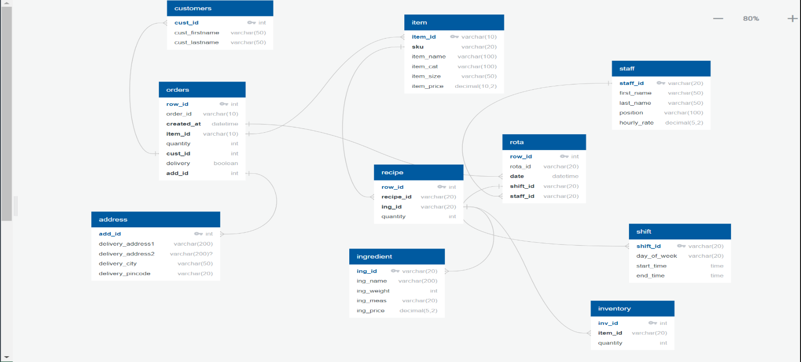
Fig 3.2. Schema diagram for Portfolio analytics
3.2 ER diagram
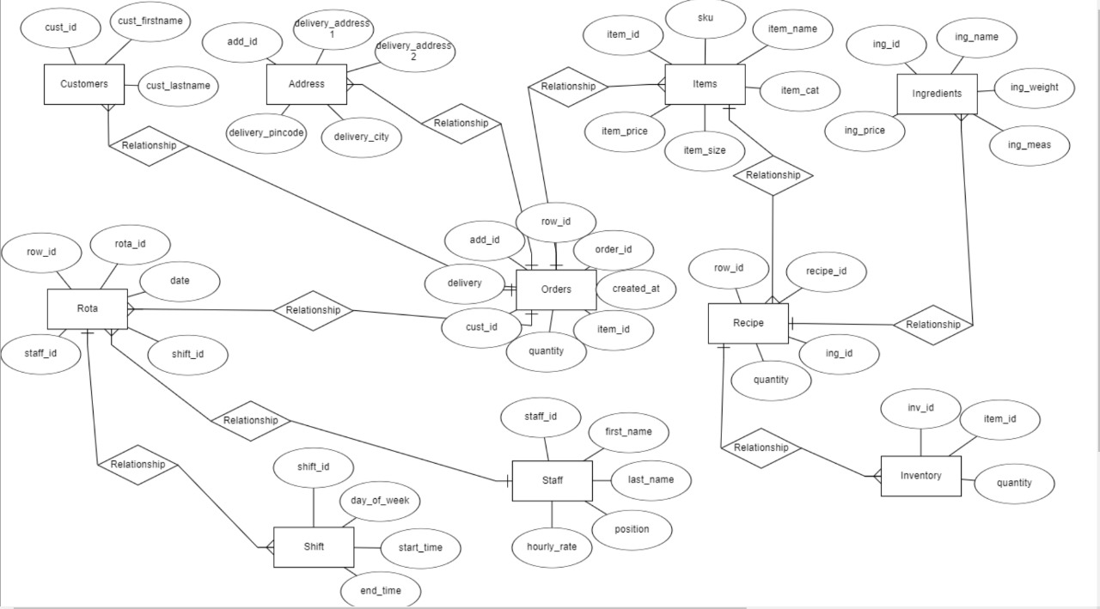
Fig 3.2. ER diagram for Portfolio analytics

CHAPTER 4
SYSTEM IMPLEMENTATION
Implementing portfolio analytics involves several key steps and considerations. Here’s a structured approach to implementing a portfolio analytics system:
- Define Objectives and Scope:
  - Clearly define what you aim to achieve with portfolio analytics (e.g., risk management, performance evaluation, asset allocation).
  - Define the scope of the analytics (types of assets, frequency of analysis, level of detail).
- Data Collection and Integration:
  - Gather historical and current data on assets in the portfolio.
  - Integrate data from various sources (market data providers, internal databases, APIs).
- Data Cleaning and Validation:
  - Cleanse data to remove inconsistencies, errors, and missing values.
  - Validate data integrity and accuracy to ensure reliable analysis.
- Performance Measurement:
  - Calculate metrics such as returns, volatility, Sharpe ratio, and other risk-adjusted performance measures.
  - Benchmark portfolio performance against relevant indices or peer groups.
- Risk Assessment:
  - Measure portfolio risk using metrics like standard deviation, Value at Risk (VaR), and Conditional Value at Risk (CVaR).
  - Conduct stress testing and scenario analysis to assess potential losses under adverse conditions.
- Asset Allocation and Optimization:
  - Use optimization techniques (e.g., mean-variance optimization) to determine optimal asset allocation.
  - Consider constraints such as risk tolerance, liquidity needs, and regulatory requirements.
- Reporting and Visualization:
  - Develop reports and dashboards to communicate findings effectively.
  - Visualize portfolio analytics using charts, graphs, and tables for easier interpretation.
- Implementation of Analytics Tools:
  - Utilize specialized software or platforms (e.g., Python libraries like Pandas, NumPy, and financial libraries such as QuantLib or dedicated portfolio management software) for analytics.
- Continuous Monitoring and Adjustment:
  - Implement processes for ongoing monitoring of portfolio performance and risk.
  - Adjust strategies based on new data, market conditions, and changes in investment goals.
- Compliance and Regulatory Considerations:
  - Ensure compliance with relevant regulations and reporting standards (e.g., SEC regulations, IFRS standards).
By following these steps, organizations can effectively implement portfolio analytics systems to make informed investment decisions, manage risks, and optimize portfolio performance.

4.1 MODULES:
Portfolio analytics typically involve several core modules or components that perform specific functions in analyzing and managing investment portfolios. These modules are essential for understanding portfolio performance, assessing risk, and optimizing asset allocation. Here are the core modules typically found in portfolio analytics systems:
- Data Management:
  - Data Collection: Gathering data from various sources including market data providers, internal databases, and APIs.
  - Data Cleaning and Validation: Ensuring data accuracy, removing errors, and handling missing values.
  - Data Integration: Consolidating data from different sources into a unified format for analysis.
- Performance Measurement:
  - Return Calculation: Computing returns for individual assets and the overall portfolio.
  - Benchmarking: Comparing portfolio performance against relevant benchmarks or indices.
  - Risk-Adjusted Performance Metrics: Calculating metrics like Sharpe ratio, Treynor ratio, and Information ratio to evaluate risk-adjusted returns.
- Risk Assessment:
  - Risk Metrics: Calculating risk measures such as standard deviation, Value at Risk (VaR), and Conditional Value at Risk (CVaR).
  - Stress Testing: Assessing portfolio performance under extreme market conditions.
  - Scenario Analysis: Modeling potential outcomes based on different economic scenarios.
- Asset Allocation and Optimization:
  - Mean-Variance Optimization: Determining the optimal allocation of assets based on expected returns and risk.
  - Constraints Management: Incorporating constraints such as regulatory limits, liquidity requirements, and client preferences.
  - Factor Analysis: Assessing the impact of different factors (e.g., economic indicators, market trends) on portfolio performance.
- Reporting and Visualization:
  - Reporting Tools: Generating reports summarizing portfolio performance, risk metrics, and compliance with investment mandates.
  - Visualization: Creating charts, graphs, and dashboards to visualize portfolio analytics for easier interpretation by stakeholders.
- Compliance and Regulatory Reporting:
  - Compliance Checks: Ensuring adherence to regulatory requirements and internal policies.
  - Audit Trail: Maintaining an audit trail of activities and decisions related to portfolio management.
  - Regulatory Reporting: Generating reports required by regulatory authorities (e.g., SEC filings, MiFID II compliance).
- Decision Support Tools:
  - Scenario Planning: Simulating different investment scenarios to assess their impact on portfolio outcomes.
  - Portfolio Rebalancing: Recommending adjustments to asset allocations based on changing market conditions and investment objectives.
  - Performance Attribution: Analyzing the sources of portfolio performance (e.g., asset allocation decisions, security selection).
- Portfolio Construction:
  - Optimization Algorithms: Implementing algorithms to construct portfolios that meet specific objectives (e.g., maximizing returns for a given level of risk).
  - Diversification Analysis: Evaluating the diversification benefits across different asset classes and geographical regions.

CHAPTER 5
SNAPSHOTS AND RESULTS
5.1 Report of orders page
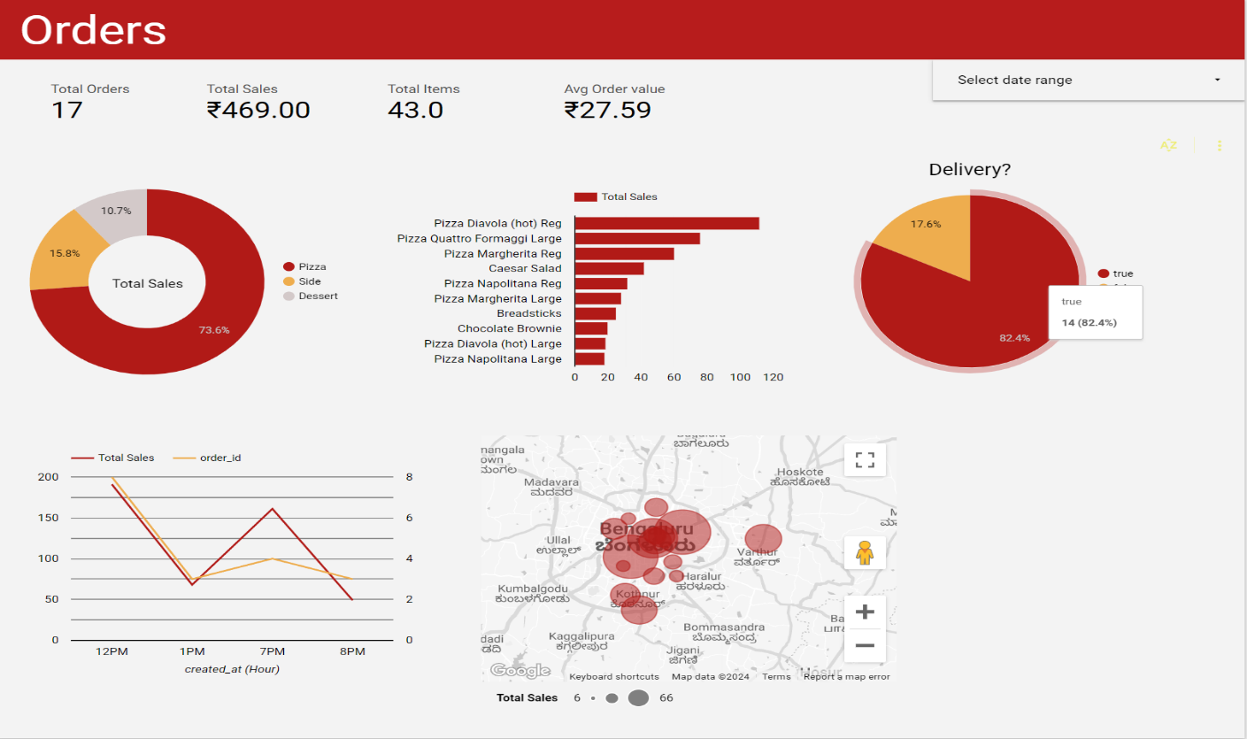
5.2 Report of Inventory page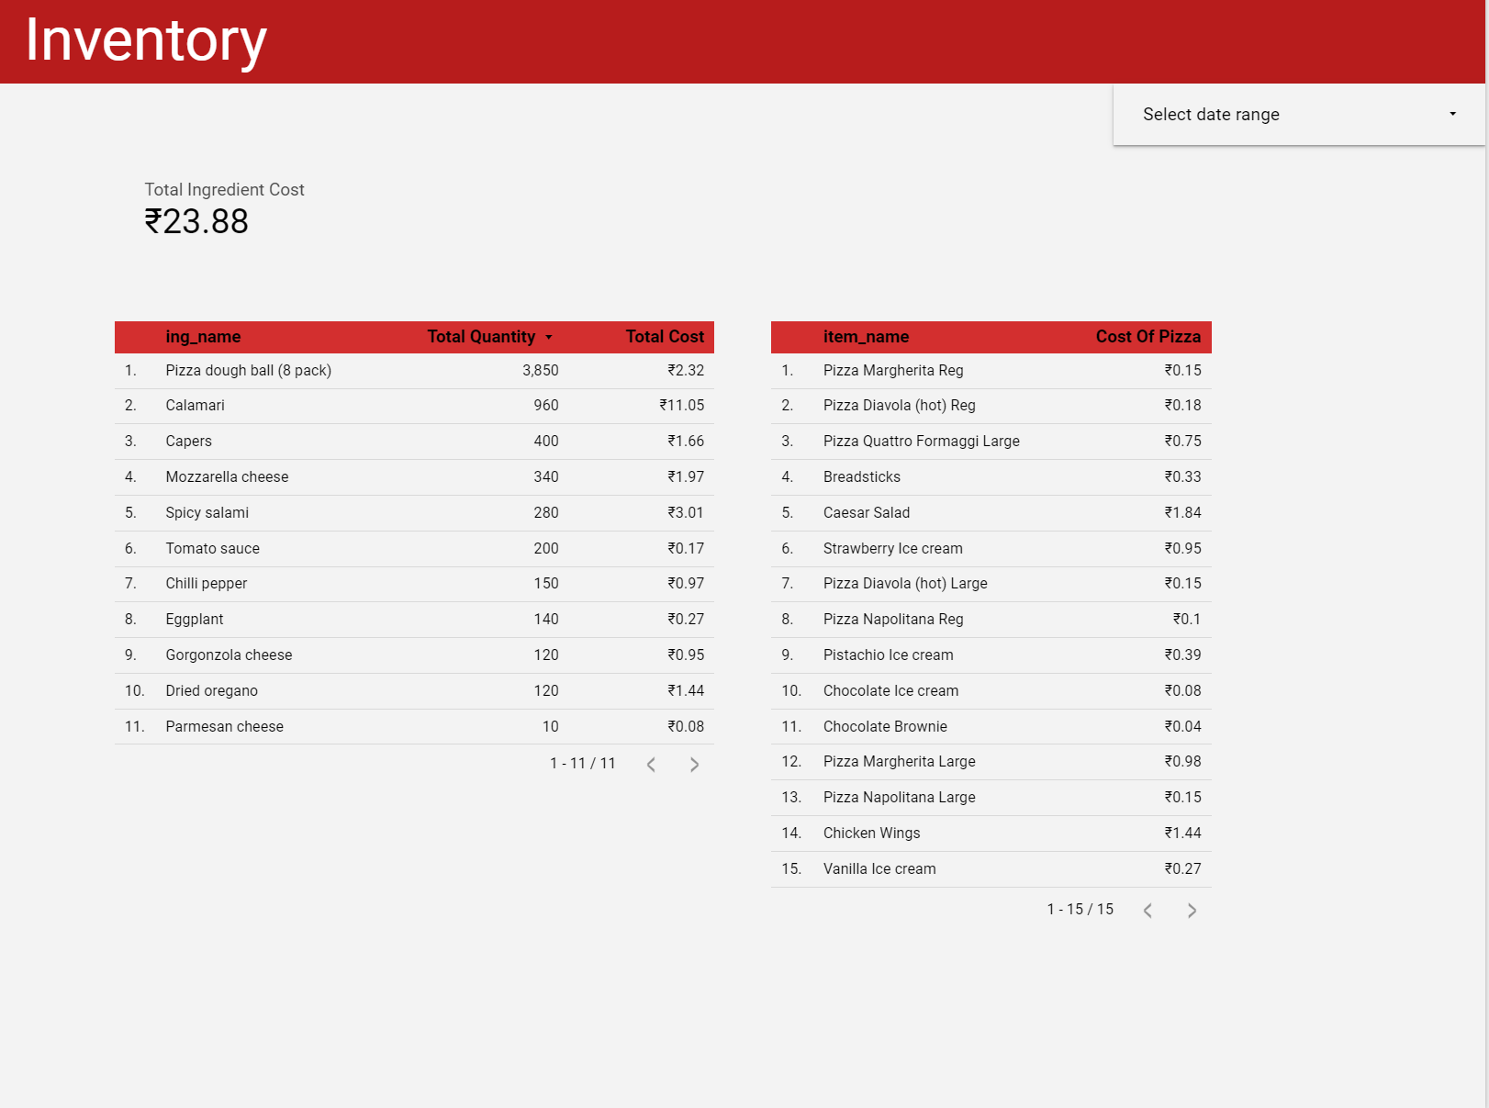
5.3 Report of Staff page
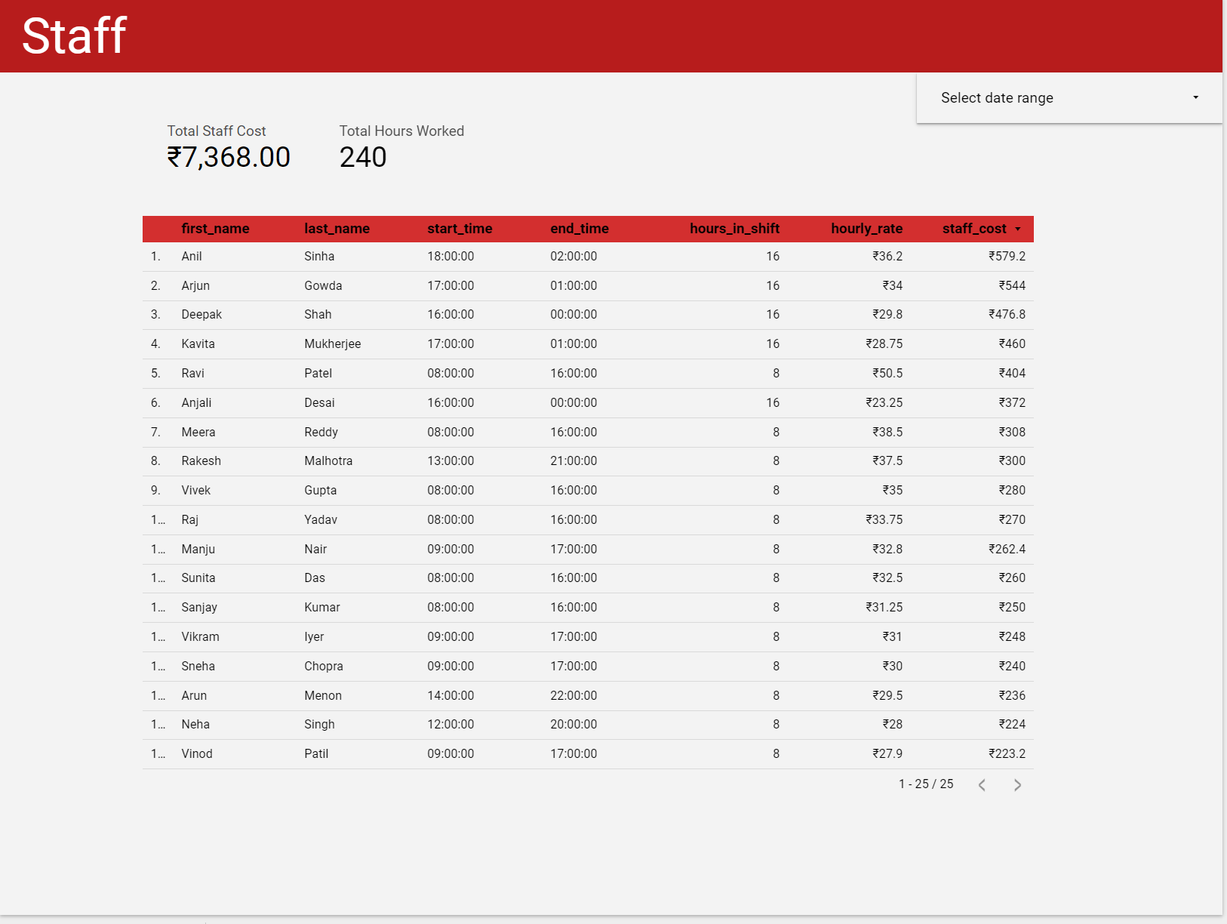

CHAPTER 6
CONCLUSION
Portfolio analytics is a critical tool in modern finance, offering invaluable insights into the performance, risk, and optimization of investment portfolios. By harnessing data from various sources and employing sophisticated analytical techniques, portfolio analytics enables investors and asset managers to make informed decisions that align with their financial objectives and risk tolerance.
At its core, portfolio analytics involves several key components: data management, performance measurement, risk assessment, asset allocation, reporting, and decision support. These components work synergistically to provide a holistic view of portfolio dynamics, from understanding historical performance to forecasting future outcomes under different scenarios.
The significance of portfolio analytics lies in its ability to enhance decision-making processes. By calculating risk-adjusted returns, assessing portfolio diversification, and optimizing asset allocations based on investor preferences and market conditions, portfolio analytics helps mitigate risks and maximize returns. Moreover, compliance with regulatory standards and reporting requirements ensures transparency and accountability in portfolio management practices.
In conclusion, portfolio analytics is not just a tool but a strategic imperative for financial institutions, asset managers, and individual investors alike. It empowers stakeholders to navigate the complexities of financial markets with confidence, adapt to changing economic conditions, and ultimately achieve their investment goals efficiently and effectively. As technology continues to advance, the evolution of portfolio analytics promises to further refine investment strategies and drive innovation in the realm of wealth management and financial planning.

